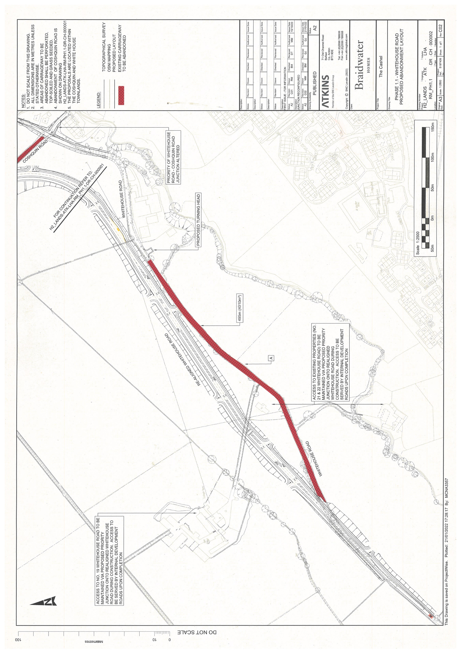

DEPARTMENT FOR INFRASTRUCTURE
Map No. IN1/22/150289 referred to in “The Whitehouse Road, Londonderry (Abandonment) Order (Northern Ireland) 2022” made by the Department on 26th October 2022 and coming into operation on 5th December 2022.

©Based upon the Ordnance Survey map with the Permission of the Director and the Chief Executive.
Crown Copyright SCALE 1:2500

Area to be abandoned

