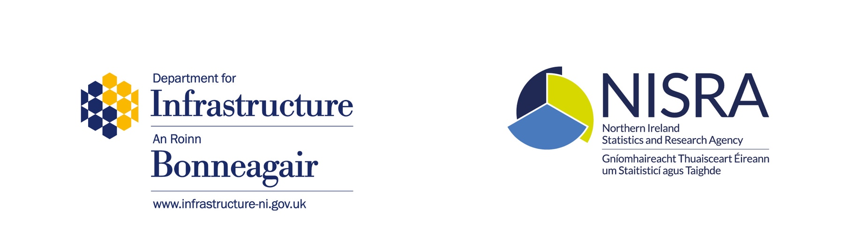

User Engagement on “Average Journey Time on Key Economic Corridors” Statistical Report
The “Average Journey Time on Key Economic Corridors” statistical report (link) presents an estimate of the average journey time on key economic corridors (KECs) in Northern Ireland.
Introduction

This statistical report presents an estimate of the average journey time on key economic corridors (KECs) in Northern Ireland in 2016 to 2018 and has been produced in accordance with the Code of Practice for Statistics (link).

Background

The “Average Journey Time on Key Economic Corridors” statistical report was published following a data development project initiated when a need for data to measure the indicator “Average journey time on key economic corridors”’ was identified and added to the draft Programme for Government (PfG) data development agenda.

Why we are asking for views
It is proposed that publication of this report is withdrawn, with the published 2016-2018 edition being the final report. Indicators included under the former draft Programme for Government are no longer being monitored.

In light of this, ASRB statisticians would welcome your views on the cessation of this statistical report and would be grateful if you completed the following short survey: -

https://www.surveymonkey.co.uk/r/JourneyTime
Please submit your response to this proposal no later than Tuesday 3 August 2021.
A copy of the user engagement survey is also available in Annex A of this document. Contact details are provided at the end of the form.
An anonymised summary of the results and the outcome of this user engagement will be published on the DfI website.
The survey should take approximately five minutes to complete.

Annex A User Engagement Survey
- Are you aware of the statistical report “Average Journey Time on Key Economic Corridors”?
Yes | Please go to Q2
No | No further responses are required

- Have you used the statistics within the “Average Journey Time on Key Economic Corridors” report?
Yes | Please go to Q3
No | No further responses are required

- If your answer was Yes to Q2 … What do you use the “Average Journey Time on Key Economic Corridors” report for (please select all that apply): -
Programme for Government
Briefing (eg to Ministers / colleagues)
Policy development / review
Academic or other research
Transport modelling/planning
Media use
Commercial purposes
Personal use
General information

Other, (please specify below): -

- How often do you make use of the “Average Journey Time on Key Economic Corridors” report?
Monthly
Quarterly
Annually
Ad hoc

- Which sources of Journey Time information do you use (please tick all that apply)?

Main Report
Infographic
Tables and figures

Other, (please specify below): -

- Are you supportive of our proposal to cease production of the “Average Journey Time on Key Economic Corridors” report?
Yes | Please go to Q7
No | If no, can you provide reasons why you do not support the proposal

Please provide reasons why you do not support the proposal to cease the publication

- Please provide any general feedback on the “Average Journey Time on Key Economic Corridors” report below: -

- Please provide your contact details below if you are content that ASRB can contact you about your responses: -
Contact details: -
Name
Organisation (if applicable)
Phone
Email

Note: - your contact details will only be used in relation to this user engagement and will be deleted once responses are analysed and clarified
Responses should be returned no later than Tuesday 3 August 2021

Please return in writing to: Analysis, Statistics & Research Branch
Room 4.13C
Clarence Court
10-18 Adelaide Street
Belfast
BT2 8GB

or by email to: ASRB@infrastructure-ni.gov.uk
Many thanks for your response.

