Safe and Accessible Travel Division

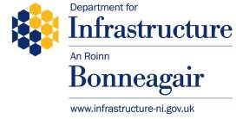
Room 3.09 Clarence Court
10-18 Adelaide Street Town Parks
Belfast BT2 8GB

Email:
DrivingPolicyBranch@infrastructure-ni.gov.uk

6th September 2023

Dear Consultee

A CONSULTATION TO CONSIDER EXTENDING THE VALIDITY PERIOD OF UKRAINIAN DRIVING LICENCES IN NORTHERN IRELAND

Purpose of Consultation

Since the beginning of the conflict with Russia, Northern Ireland has been putting measures in place to assist those Ukrainian nationals who have arrived here after fleeing the conflict.

The purpose of this consultation is to seek views on a proposal to further support Ukrainian nationals in NI by extending beyond the current 12-month period, the time during which the holder of a Ukrainian driving licence is able to drive cars in NI on that licence after becoming resident. This course of action would align with legislative amendments currently being introduced in GB and be similar to temporary measures already in place in the EU.

You are invited to give your views, comments and ideas in respect of any aspect of the paper.

How to respond

The consultation opens today and will run until 23:59 on 3rd October 2023. You are invited to access the document and respond online or visit the consultation page on the DfI website

Yours sincerely

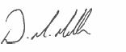
D Mullan, Head of Driving Policy Branch
Safe and Accessible Travel Division

