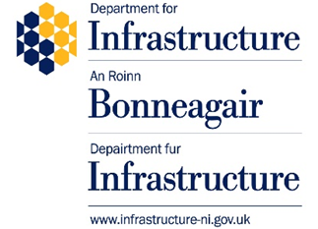

Extension to the validity period of Ukrainian driving licences in Northern Ireland

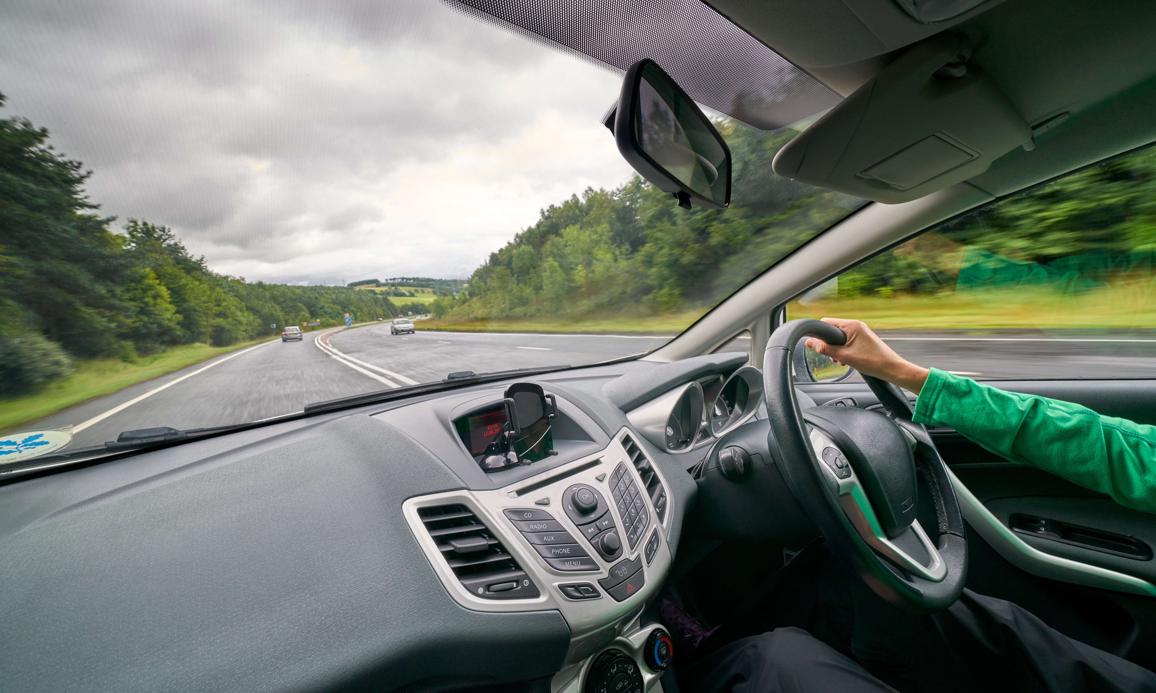
Public Consultation

Date: 6th September 2023

Contents Page

Background and context 3
Why we need to do this 4
What we are proposing 5
Rationale and potential impacts 6
Road safety considerations 8
How to respond 10
Confidentiality & Data Protection 11
Impact assessments 12
What will happen next 12
Questionnaire 13

BACKGROUND AND CONTEXT

The UK has been playing a leading role in supporting Ukraine and until the conflict with Russia is resolved, will continue to do so.

To help make the transition to life in the UK as seamless as possible for those arriving under such difficult circumstances, the UK Government has established three official schemes for Ukrainian refugees to come to the UK which are jointly administered by the Home Office and the Department of Levelling Up, Housing and Communities. Whilst local implementation will be subject to the guidance and regulations set out by the UK Government in establishing the schemes, the Executive Office (TEO) is co-ordinating the support and delivery of key services to those who arrive working in partnership with the UK Government, other Devolved Administrations, NI Executive Departments, Statutory Agencies and the voluntary and community sector.

Initiatives such as the Free Onward Travel Scheme have all made it easier for Ukrainians to travel and settle into life in the UK.

However, continuing this transition is not always straightforward, and one area where Ukrainian arrivals have to adapt is in motoring. The continued ability of Ukrainians to get around is vital to their integration, socialising, accessing healthcare and working during their time in NI.

In NI, we allow all those driving on non-UK, non-EEA driving licences who become resident, 12 months before we require them either to exchange their licences if eligible, or to take a driving test in order to continue driving here. As with some other countries, NI has a driving licence exchange agreement with Ukraine, and Ukrainian driving licences can be exchanged for NI licences. However, only Ukrainian licences issued after 28 December 2021 specify the type of vehicle transmission that a driver passed their test in. Therefore, licences that were issued prior to this date can only be exchanged for a NI licence which restricts the driver to driving automatic vehicles. For those Ukrainians with licences issued before this date, to obtain a NI manual licence they must take a NI manual test.

This is a particular issue for those who have brought manual vehicles with them to NI and may lose the right to drive them, despite planning to return home to Ukraine when it is safe to do so.

Given the exceptional and temporary nature of Ukrainians’ residence in Great Britain (GB) under the Ukrainian Visa Schemes, and to deal with this issue, the Department for Transport recently extended, following consultation, the time during which the holder of a Ukrainian driving licence is able to drive cars in GB on that licence after the holder becomes resident, beyond the current 12-month period to 3 years (36 months). This matches the visa length they have been given (the Family, Sponsor and Extension visa schemes have all been given 3-years lengths).
This will improve Ukrainian licence holders’ ability to get around and adapt to living in GB as they will not need to exchange their licence or take a further test during the extended period in order to continue driving a manual car, including any such vehicle they brought with them to GB.

WHY WE NEED TO DO THIS

For the first 12 months of being resident in NI, Ukrainians are able to use their Ukrainian licence here to drive all classes of small vehicles authorised by that licence, both automatic and/or manual vehicles (car), unless the licence shows a restriction.
In October 2022, legislation was put in place to allow a Ukrainian car licence to be exchanged for a NI licence without the need to take a NI driving test. This followed Ukrainian testing standards being assessed as equivalent to those in GB by the Driver and Vehicle Standards Agency. However, the law only allows drivers who took a test in Ukraine before 28 December 2021 to be issued with a NI licence to drive vehicles with automatic transmission when their Ukrainian licence is exchanged. This is because the Ukrainian driver licensing authority does not retain information to confirm whether a test was taken in a manual or automatic vehicle before this date.
A Ukrainian licence holder who exchanges their licence for a NI licence but is restricted to driving automatic vehicles, can upgrade this by passing a manual practical test for which they would not be required to pass a NI theory test.
The current requirement for a holder of a Ukrainian driving licence who is resident in NI to exchange it for a NI licence after 12 months to continue driving without passing a NI test, has specific impacts on Ukrainian licence holders who have arrived as part of schemes to provide refuge from the current conflict.
The restriction to entitlement to drive vehicles with automatic transmission is not unique to the exchange arrangement for Ukrainian licence holders. It is also applied to driving licence exchange arrangements with other countries that do not hold information to confirm the type of vehicle in which a test was taken. However, evidence received by the Department for Transport and its agencies suggests that a number of those arriving here because of the conflict have fled with their own car.
The Ukrainian licencing authority, until 28 December 2021, did not record the transmission of the vehicle presented for test and would award a successful test candidate for both manual and automatic vehicles. This information is now recorded, and a successful test candidate is awarded either an automatic licence or manual licence. Many of these licence holders own a car with manual transmission.
In these circumstances, the requirement to exchange and the issue of a NI licence restricted to vehicles with automatic transmission, means the majority of individuals would no longer be able to drive their vehicle in NI.
To continue driving, they would need to either dispose of their existing car and incur the cost of acquiring a new vehicle with automatic transmission or incur the £45.50 cost of a NI manual driving test. This would be in addition to the £62.50 cost of exchanging their Ukraine licence and assumes a first-time pass. Evidence from representations also suggests that even those without their own car may on exchange lose the ability to drive cars they have been given use of by their hosts.
These issues are of course faced by other holders of foreign licences living in NI, including asylum seekers and refugee groups. However, the circumstances of Ukrainians in NI because of the conflict may be distinct. It is unlikely that large numbers from other refugee groups will have arrived in NI with their own car and, unlike those who have come to live in NI for other reasons (e.g. to take up employment or join family), Ukraine licence holders fleeing the conflict are unlikely to have had the opportunity to plan for the driving licence issues they now face.
Also, typically those arriving under the Ukrainian visa schemes (Family, Sponsor and Extension) are allowed to stay for up to 3 years with the intention that they return to Ukraine as soon as circumstances allow. Other schemes such as the Afghan Citizens Resettlement Scheme and the British National Overseas Visa Scheme for those from Hong Kong provide for the applicant to remain permanently.

In this context, the requirement to exchange a Ukrainian licence and then apply for its reinstatement on return to Ukraine (exchangeable driving licences have to be surrendered on application for a NI licence and, if exchanged, are returned to the issuing authority) represents a potentially unnecessary burden. Any Ukrainian that stays in NI beyond the time period of their Ukraine scheme visa and who had passed their test in Ukraine before 28 December 2021 would be expected to then undergo a manual practical test should they want a manual entitlement licence.

WHAT WE ARE PROPOSING

The Department is proposing to extend the period of time during which the holder of a Ukrainian driving licence is able to drive in NI all classes of small vehicles authorised by that licence. And, therefore, the time after which a Ukrainian licence must be exchanged for a NI licence if the Ukrainian licence holder wishes to continue driving in NI without taking a test.
This period of time is currently 12 months after the licence holder becomes resident and the proposal is to extend it to 36 months (3 years) to match the length of the visa they have been given (Family, Sponsor and Extension visa schemes).
This consultation seeks views on this proposed extension and provides the opportunity for other comments. We are not seeking to allow them to drive on their Ukrainian licence indefinitely. This change can be made by secondary legislation.
This would allow Ukrainian licence holders to continue using their Ukrainian licence in NI for a longer time period, or, up to the point in time at which they either leave the UK or their visa expires.
This extension would only apply to Category B (Car). Licences in other categories are not being considered at this time.

Question
Do you agree or disagree with our proposal of extending the eligibility period of time for which Ukrainian licence holders, arriving from the Russian conflict, may drive cars within NI from the current 12-month entitlement to a maximum of 36 months (3 years) to match the full Ukrainian visa scheme period?

RATIONALE AND POTENTIAL IMPACTS

Requiring Ukrainian refugees to get a NI driving licence when they already have a Ukrainian licence introduces an administrative and financial burden to Ukrainian arrivals, that could impact on their integration into NI and the ability to continue their lives smoothly (e.g. access employment, education, and health opportunities). To note, this does apply to other refugee groups who also face this barrier.
This requirement introduces processes that are potentially unnecessary for Ukrainians in the short term, given their stay in NI is not expected to be permanent. However, where a Ukrainian national stays in NI beyond their initial Home Office issued visa (potentially under indefinite leave to remain), they will be expected to follow standard processes to exchange their licence for a NI one.
The current requirement also makes it potentially more challenging for Ukrainians who have a driving related job or who need to drive in order to get to work from working for a short period of time (however, this might be offset by employers resolving this issue for their Ukrainian drivers), or for a longer period of time if they cannot afford the fees associated with getting a NI driving licence. Likewise, any Ukrainian who brought a manual vehicle to NI, may face the additional burden of not having the right to drive it after 12 months. They could also potentially illegally drive in NI if they are unaware of this requirement.
The proposal would potentially remove the financial and administrative burden of licence exchange and issues relating to the restriction of NI driving entitlement to the driving of vehicles with automatic transmission.
This is in line with the joint approach being taken to support Ukrainian nationals wherever possible both during their time in the UK and to make returning to Ukraine as straightforward as possible.
There are, however, risks that by extending the period of time during which a Ukrainian licence holder is treated as the holder of a licence authorising the holder to drive cars in NI, motor insurance providers may refuse to offer motor insurance or charge higher premiums to Ukrainian drivers that do not exchange their licence, as this is a risk that insurers have never previously priced against. Of course, treating Ukrainian licence holders as the holder of a licence authorising the driving of cars in NI for a longer period after becoming resident would not preclude them from choosing to exchange their licence earlier.
An extension could be argued to pose additional road safety risks, particularly given the issue around the unknown nature of tests for licences issued before 28 December 2021. However, compared to many other foreign licences, there is some reassurance in the fact that Ukraine’s driving test and licensing standards have been assessed as equivalent to those in NI and the right to use the licence will remain time limited in the line with the temporary nature of their intended stay.
The extent of potential benefits and risks is difficult to assess as exact numbers of Ukraine licence holders in NI is unknown. Figures obtained from DVA driver records show that from October 2022 to date, 142 Ukraine driving licences were exchanged for a NI one.
Figures published on 24 August 2023 show 185,000 Ukrainian nationals have so far arrived in the UK under one of the visa schemes and 28,000 have been granted an extension to an existing permission to stay because of the conflict. By 26 June 2023 NI had welcomed 2,645 Ukrainian nationals, under a combination of the three schemes (Homes for Ukraine Scheme, Family Scheme and the Extension Scheme). It is possible though that a significant number of these hold a Ukraine driving licence and could, under current rules, be approaching the point where they need to obtain a NI licence and so could benefit from an extension.
Also, if an extension is applied only to Ukrainian licence holders, there is a potential for confusion for enforcement given the existing provision applies to all foreign licences issued outside the EEA and regardless of whether they are exchangeable or not. Any extension for Ukrainian licences would need to be clearly communicated given that they would be treated differently, and the 12-month rule would remain in place for all other foreign licences.
It is possible that some Ukrainian licence holders who are resident in NI are not here as part of the schemes (Family, Sponsor and Extension visa schemes) designed to give temporary refuge for those displaced by the conflict. However, it is expected that numbers will be low.

ROAD SAFETY CONSIDERATIONS

The longer the conflict goes on in Ukraine, the longer arrivals will remain here and as weeks pass into months, so too will Ukrainians want to build some semblance of normality in their day to day lives. This will include working, getting around and travelling for leisure activities.
As the rules currently stand, visitors to NI who hold a full and valid foreign driving licence, can drive here on that licence for up to 12 months. This allows those drivers time to:
• become familiar with our roads, driving on the left, road signage and signs written in English (rather than pictograms); and
• get a NI driving licence (either via the test route, or exchange if eligible) if they intend staying in NI.
It could be considered that the period of greatest risk is when visitors are first in NI and are already permitted to drive using their Ukrainian licence. The risk should lessen the longer they are driving in NI and, the more experience they gain, so there would be reduced risk associated with increasing the validity period of a Ukrainian licence from 12 to 36 months.
Under the current rules there is an opportunity to assess the skills of those Ukrainian licence holders, who would require a driving test in a manual vehicle within 12 months of becoming resident, to retain their manual entitlement. If drivers are not up to the required standard a NI manual licence would not be granted (This does not apply to entitlement to drive an automatic vehicle, which would continue to be valid on exchange). Any delay to this manual testing opportunity could be considered a road safety risk, however this testing is only required before the end of the 12 month ‘grace’ period, not upon first arrival to NI. Extending the ‘grace’ period from 12 months to 36 months is unlikely to increase this risk further.

Questions
The following questions are included here so you can read them in the context of this document.

Question
What comments, if any, do you have on our suggested road safety considerations?

Question
Are there any other road safety considerations you would like to see included?

Question
Any other comments?

HOW TO RESPOND
The 4-week consultation period will begin on 06 September 2023 and will run until 03 October 2023 at 23:59. Please ensure that your response reaches us before the closing date.
Where possible, your response should be made via Citizen Space on the NI Direct website using the following link: https://consultations2.nidirect.gov.uk/dfi-1/ukrainian-driving-licence-exchange-extension/
or alternatively at:
https://www.infrastructure-ni.gov.uk/consultations/extending-validity-period-ukrainian-driving-licences-northern-ireland
The Department for Infrastructure has actively considered the needs of people with visual impairments in accessing this consultation document. The text will be made available in full on the Department’s website which allows for e-readers (including the most recent versions of JAWS, NVDA and VoiceOver). The text may be freely downloaded and translated by individuals or organisations for conversion into other accessible formats. Our accessibility statement at https://www.infrastructure-ni.gov.uk/department-infrastructure-accessibility-statement gives more information.
Please ensure that your response reaches us before the closing date. If you would like further copies of this consultation document, it can be found at Department Website (https://www.infrastructure-ni.gov.uk/consultations/extending-validity-period-ukrainian-driving-licences-northern-ireland) or you can contact the Department at DrivingPolicyBranch@infrastructure-ni.gov.uk if you need alternative formats (Braille, audio CD, etc.).

Responses to the consultation should be made online via Citizen Space as indicated above or, if that is not possible, by e-mailing to: DrivingPolicyBranch@infrastructure-ni.gov.uk
When responding, please state whether you are responding as an individual or representing the views of an organisation.
If responding on behalf of a larger organisation, please make it clear who the organisation represents, and where applicable, the number of members and how the views of those members were assembled.
If you have any suggestions of others who may wish to be involved in this process, please contact us.

CONFIDENTIALITY & DATA PROTECTION

Information contained in your response may be made public by DfI. If you do not want all or part of your response made public, please state this clearly in the response by marking your response as ‘CONFIDENTIAL’. Any confidentiality disclaimer that may be generated by your organisation’s IT system or included as a general statement in your correspondence will be taken to apply only to information in your response for which confidentiality has been specifically requested. Information provided in response to this consultation, excluding personal information, may be subject to publication or disclosure in accordance with the access to information regimes (this is primarily the Freedom of Information Act 2000 (FOIA)).
The Department will process your personal data in line with the Department’s Privacy Notice. Personal data provided in response to this consultation will not be published.
If you want other information that you provide to be treated as confidential, please be aware that, under the FOIA, there is a statutory Code of Practice with which public authorities must comply and which deals, amongst other things, with obligations of confidence. In view of this, it would be helpful if you could explain to us why you regard the information you have provided as confidential. If we receive a request for disclosure of the information we will take full account of your explanation, but we cannot give an assurance that confidentiality can be maintained in all circumstances. An automatic confidentiality disclaimer generated by your IT system will not, of itself, be regarded as binding on the Department.
As indicated above, the Department will publish a summary of responses following completion of the consultation process. Your response, and all other responses to the consultation, may be disclosed on request. The Department can only refuse to disclose information in exceptional circumstances. Before you submit your response, please read the paragraph below and it will give you guidance on the legal position about any information given by you in response to this consultation.
The Freedom of Information Act 2000 gives the public a right of access to any information held by a public authority, namely, the Department in this case. This right of access to information includes information provided in response to a consultation or a call for evidence. The Department cannot automatically consider as confidential information supplied to it in response to a consultation or a call for evidence. However, it does have the responsibility to decide whether any information provided by you in response to this consultation, excluding information about your identity, should be made public or treated as confidential.
For further details on confidentiality, the FOIA and the EIR please refer to www.ico.org.uk .

Impact Assessments
The overall purpose of the proposal is to help support those Ukrainians fleeing the conflict with Russia by extending the time during which the holder of a Ukrainian driving licence is able to drive cars in NI on that licence after becoming temporarily resident in NI under one of the refugee visa schemes, potentially from 12 to 36 months.
The Department has carried out the following impact assessment screens on the proposal:
- Equality Impact Assessment Screen
- Regulatory Impact Assessment Screen
- Rural Impact Assessment Screen
- Human Rights Impact Assessment Screen
- Data Protection Impact Assessment Screen
The impact assessment screens have found no undue impacts arising from the proposal in this consultation. The impact assessment screens will be kept updated so that they reflect the development and implementation of policy. The Department will, as is required, published the equality impact assessment screens to the Departmental website.

What will happen next
A summary of responses, including the next steps, will be published within 3 months of the consultation closing.
If you have questions about this consultation, please contact:
DrivingPolicyBranch@infrastructure-ni.gov.uk

QUESTIONNAIRE - EXTENSION TO THE VALIDITY PERIOD OF UKRAINIAN DRIVING LICENCES IN NORTHERN IRELAND

- Name (Optional):

- Email address (Required):

- Are you responding as an individual or representing the views of an organisation: (Required)

- Individual ☐
- Organisation ☐

Organisation
Details of organisation and how members’ views were gathered.

3a. What is the name of the organisation? (Required)

3b. Who does the organisation represent?

3c. If applicable, how were the views of the members of the organisation collected?

- Do you agree with our proposal of extending the eligibility period of time for which Ukrainian licence holders, arriving from the Russian conflict, may drive cars within NI from the current 12-month entitlement to a maximum of 36 months (3 years) to match the full period of the Ukrainian visa schemes? (Required)

Yes ☐
No ☐

If you do not agree with the proposal please provide your reasons.

- Do you have any comments on our suggested road safety considerations?
If yes, please provide details:

- Are there any other road safety considerations you would like to see included?
If yes, please provide details:

- Have you any other comments?
If yes, please provide details:

