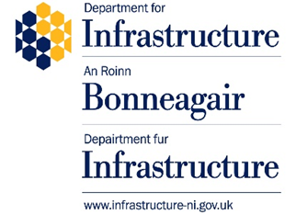

Approach to Authorisation for the Placing in Service of Subsystems under the Railways (Interoperability in Northern Ireland) Regulations 2026

Guidance for Applicants

April 2026
Contents
Foreword 3
1. Introduction 4
2. References 6
3. The Department’s roles and responsibilities 7
The Authorisation Process 7
Pre-Application Engagement 9
Stage Gate Reviews – New Subsystems 10
Stage Gate Reviews – Upgraded or Renewed Subsystems 11
Assessment of major projects 12
Technical File submission and approval 13
4. Approach to Authorisation 15
Assessment of the change 15
Authorisations for Fixed Infrastructure 16
Authorisations for Rolling Stock 17
Authorisations for Control-Command and Signalling 18
Large packages of work 19
Interfaces Between Systems 19
5. Regulatory Environment 21
Interoperability Regulations 21
The role of CSM-RA in Interoperability 22
The role of conformity assessment bodies 23
Assessment Body (AsBo) 23
Notified Body (NoBo) 23
Designated Body (DeBo) 24
Expectations of Applicants 25
6. Glossary & Definitions 26
Appendix A: General Information about Interoperability 29
Appendix B: Structure for Early Engagement for New Subsystems 30
Appendix C: Structure for Early Engagement for Upgrades & Renewals 32
Appendix D: Stage Gate and Submission Checklist 34
Appendix E: Annex IV ‘EC’ Declaration of Verification for Subsystems 36

Foreword

This guidance clarifies the expectations of the Department for Infrastructure (the Department) as the Competent Authority for Interoperability (including interoperability authorisations), and on those making authorisation applications. It provides a recommended process for Applicants engaging with the Department in developing the authorisation submission. The Department emphasises early engagement to identify and resolve potential barriers to successful applications earlier in the project lifecycle.

The early engagement process described here should therefore provide confidence to Applicants that authorisation will not be a barrier to meeting project timescales, will help spread workload associated with authorisation applications more evenly across the project lifecycle, and substantially reduce (or eliminate) the number of Conditions applied to authorisations through enhancing application quality.

Whilst this process is not mandatory, Applicants choosing to follow the approach outlined in this document will be able to better integrate authorisation applications in their project planning. Applicants following this process are therefore more likely to receive authorisations without Conditions in a timely manner, making the whole process more efficient for everyone involved.

Introduction

  - The Railways (Interoperability) (as amended) Regulations 2011 (RIR 2011) ensure that there is a clear and accessible technical standards framework in place from 16th January 2012, and that the railway interoperability regime is maintained.

  - These regulations transposed EU Directive 2008/57/EC on the interoperability of the European rail system (‘the Interoperability Directive’). Directive 2008/57/EC was recast by Directive (EU) 2016/797 with effect from 11 May 2016.

  - In February 2023, the United Kingdom (UK) and the European Union (EU) agreed the Windsor Framework. To facilitate dual access to both the UK internal market and the EU single market, Northern Ireland (NI) applies Directive (EU) 2016/797, insofar as Conditions and technical specifications for the placing on the market, putting into service and free movement of railway products are concerned. This means that the EU’s Technical Specifications for Interoperability (TSIs) are directly applicable in NI and that ‘interoperability constituents’ and the ‘Subsystems’ into which they are assembled must demonstrate conformity with applicable TSIs to fulfil the Essential Requirements of RIR 2011. This requirement is set out in a National Technical Specification Notice (NTSN) for NI, published by the Secretary of State for Transport pursuant to Regulation 3B of RIR 2011.

  - The Railways (Interoperability in Northern Ireland) (Convention on International Carriage by Rail) (Amendment) Regulations 2026 (RINIR 2026) transposed Directive (EU) 2016/797 into UK law for NI in XXXX 2026.

  - One of the core requirements of Directive (EU) 2016/797 and the associated Interoperability Regulations, RINIR 2026, is that no structural or vehicle Subsystem can be put into use on or as part of the rail system unless an interoperability authorisation for the Placing in Service of that Subsystem has been provided.

  - The Department has developed this guidance document to set out its approach to interoperability authorisations under RINIR 2026, to formalise its expectations and provide a framework to facilitate the submission of authorisation applications of a high quality.

  - This guidance provides a framework for enhanced engagement with Applicants throughout the authorisation process and should improve the clarity of the application requirements for different types of Subsystems.

  - This guidance is not mandatory; however, it is intended to effectively support the Applicant throughout the authorisation process leading to a de-risked approach for the Applicant, resulting in the imposition of fewer Conditions to the authorisation and benefitting all stakeholders.

  - Applicants choosing not to follow this recommended approach, should produce an application to an equal standard, in a systematic and assessable format. Further clarification on this guidance and the authorisation processes can be sought from the Department (railsafety@infrastructure-ni.gov.uk).

  - General information about interoperability can be found in Appendix A.

References

  - Directive 2008/57/EC of the European Parliament and of the Council of 17 June 2008 on the interoperability of the rail system within the Community

  - Directive (EU) 2016/797 (recast of Directive 2008/57/EC) Interoperability Directive, including Amendments

  - The Railways (Interoperability) Regulations 2011 (RIR 2011) (SI 2011/3066)

  - The Railways (Safety Management) Regulations (Northern Ireland) 2006

  - National Technical Specification Notice (NTSN) for Northern Ireland (NI)

  - Technical Specifications for Interoperability (TSIs)

  - Northern Ireland National Rules (NRs)

  - Common Safety Method for Risk Evaluation and Assessment (CSM-RA) Guidance on the application of Commission Regulation (EU) 402/2013

  - Regulation (EU) 2018/545 of 4 April 2018 establishing practical arrangements for the railway vehicle authorisation and railway vehicle type authorisation

  - The Railways (Interoperability in Northern Ireland) (Convention on International Carriage by Rail) (Amendment) Regulations 2026 (RINIR 2026)

A request can be submitted to the Department (railsafety@infrastructure-ni.gov.uk) to ask for help in interpretation of any requirements in RINIR 2026, the NTSN for NI, TSIs or NRs.

The Department’s roles and responsibilities

This chapter sets out the Department’s roles and responsibilities as both the National Safety Authority and the Competent Authority, in the application process, including early engagement, and in the submission and approval process. It describes:

- the Authorisation Process

- Pre-Application Engagement (for new Subsystems)

- Stage Gate reviews throughout the process (for both new Subsystems and upgraded or renewed Subsystems)

- submission of Application and Approval

The Authorisation Process

3.1. Applicant engagement with the Department

- Project update meetings

The Applicant should engage with the Department in advance of authorisations. The Infrastructure Manager for the NI rail network engages with the Department on a bi-monthly basis on infrastructure projects. These meetings will give the project team an opportunity to provide the Department with the project background information and allow the Department to provide advice and guidance on project planning and determine if the project requires authorisation. Meeting details may include:

- project outline/scope
- project timeline
- evidence of CSM-RA Significance level assessment
- potential conformity assessment bodies to be included
- applicable TSIs and NRs
- cases where TSIs do not apply
- non-application of TSIs

  - Throughout a project the Applicant must:

- Ensure that Conformity Assessment Bodies (CABs) are engaged for individual phases of work at the design and/or production stages of the project. Any reports or comments from the CABs should be collected by the Applicant at the appropriate phase of work and submitted to the Department as part of the Technical File for the overall authorisation.

- Provide the Department, if prior agreement has been reached, with appropriate Intermediate Statements of Verification (ISVs) from the Assessment Body (AsBo) (where these are being produced), which will need to be supported by a (positive) Safety Assessment Report (SAR).

- If the change is considered Significant, obtain CSM-RA SARs, which align with, and support the ISVs and project stages. These must be included in the Technical File and demonstrate safe integration with the wider railway system.
  - The Department can only issue an authorisation for placing a Subsystem into service where it is satisfied that all of the following are demonstrated by the Applicant:

- An ‘EC’ Declaration of Verification has been drawn up that complies with Annex IV of Directive (EU) 2016/797. The requirements of Annex IV are given in Appendix E.

- The project Subsystem is technically compatible with the rail system it is being integrated into.

- The Applicant has satisfactorily completed tests in accordance with the Regulations.

- The Applicant has prepared a Technical File containing all the information and documents where they have been required by the Department.

  - In the event that the Department is not satisfied that these requirements have been met it can either reject the application, or authorise subject to Conditions, which are additional constraints on operation of the Subsystem.

  - An illustrative process for obtaining authorisation is given in Figure 3.1. Note that not all steps will be applicable for every authorisation application, particularly in the case of upgraded or renewed systems.

Figure 3.1 Process for obtaining Authorisation highlighting areas of engagement
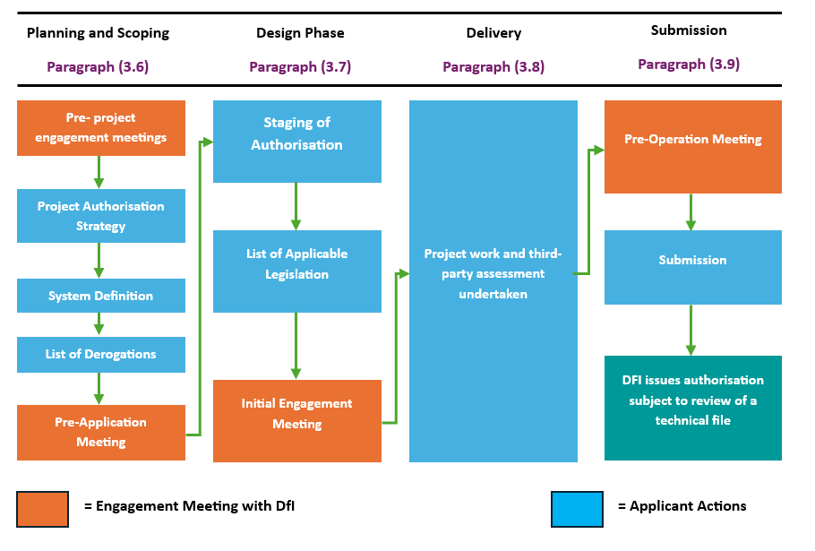
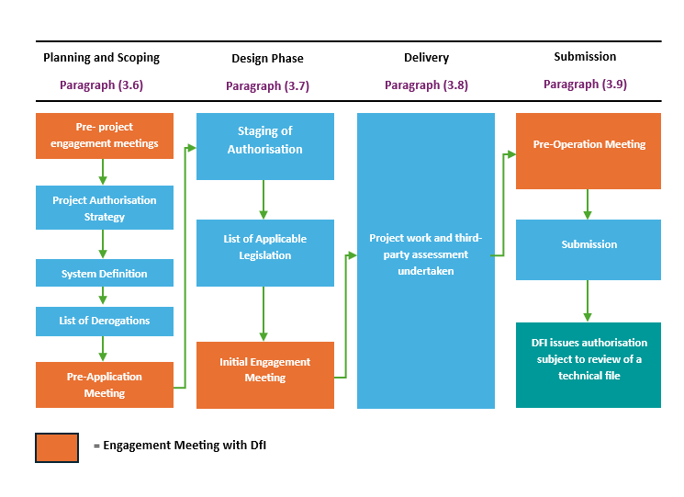
  - Where the requirement for authorisation has been determined by the Department, the Applicant should begin to plan and scope a programme of work, by producing a Project Authorisation Strategy (PAS), System Definition (SD), and a list of possible cases where TSIs do not apply or non-application of TSIs, to bring to a Pre-Application Meeting with the Department (Initial Engagement Meeting for upgraded or renewed Subsystems).

  - After this, as part of the draft PAS, the Applicant should produce the Staging of Authorisation i.e. a plan setting out the key milestones and the ISVs and assessment reports to be produced, in addition to producing a list of applicable legislation, to be brought to an Initial Engagement Meeting.

  - The Applicant should then undertake project work and independent assessment for their project or programme of work.

  - The Authorisation process concludes with a Pre-Operation Meeting, in advance of the Department’s review of the Technical File and subsequent authorisation by the Department.

  - Additional guidance specific to Infrastructure and Rolling Stock projects is given in Paragraphs 4.8 to 4.18.

  - The Applicant should send completed ISVs and SARs to the Department at Stage Gate intervals to demonstrate the progress of work. These will be used by the Department to assess the Applicant’s adherence to the agreed plan.

  - The PAS should give a clear approach for how the Applicant intends to obtain authorisation and should be followed by all Applicant project members throughout the project lifecycle. If changes occur (such as to the project scope) then it should be revised in line with these changes and provided to the Department.

  - The PAS should identify the programme stages where any required ISVs and SARs will be submitted. The PAS should also cover how the evidence will be integrated and submitted for authorisation in the final Technical File and verification declarations.

  - For all Applicants, we expect to see evidence that an internal assurance process has been followed.

  - Where the project or programme of work covers the upgrade or renewal of a Structural Subsystem that is being carried out in stages, it may be possible to group together what would otherwise be separate authorisation applications.

  - Paragraph 4.22 describes how the Applicant may treat such a project or programme of work as a single Structural Subsystem.

Pre-Application Engagement

  - When the Applicant knows that authorisation is required for a new Subsystem to be put into service, they should consult with the Department in a Pre-Application Meeting (Initial Engagement Meeting for upgraded or renewed Subsystems) to discuss the main features of the project or programme, including:

- SD including Subsystem purpose and project/programme scope

- risk management approach for design, testing and operation of the Subsystem

- planned project/programme schedule

- PAS
  - At this meeting the Department will seek to understand:

- the scale and scope of the project/programme

- the technical and operational complexity of the Subsystem

- potential impact of the project/programme on the safety of the railway network

  - The Department will pay particular attention to whether the Applicant can provide sufficient assurance that safety will not be compromised by the project or programme.

  - This meeting will involve review of the PAS, setting out how works will be undertaken and the point at which authorisation must be obtained.

  - Full guidance on the structure of the Pre-Application Meeting for new Subsystems, including what the Applicant should present, is given in Appendix B. For guidance on the Initial Engagement meeting for upgraded or renewed Subsystems see Appendix C.

  - The following two sections provide more detailed guidance on how the Department can engage with Applicants for both new Subsystems and upgraded and renewed Subsystems through a series of meetings and document reviews.

  - The Department will provide feedback from these meetings and document reviews to the Applicant through a table of comments.

  - When preparing for these meetings Applicants should understand that their purpose is not for the Department to confirm whether or not they are meeting the requirements for approval, but rather that they are an opportunity to get early feedback from the Department on potential challenges and opportunities in the authorisation process.

  - In both cases Applicants should consider the checklist in Appendix D when preparing interim submissions. When following the checklist for preparing interim documents, Applicants should update the contents of previously submitted documents before the final submission (e.g. updating the Project Lifecycle at later stages of the project).

Stage Gate Reviews – New Subsystems

  - The engagement timeline, meetings and document submissions, for new Subsystems is set out in Figure 3.2. The Applicant should take part in three formal engagement meetings with the Department throughout the project or programme lifecycle, to discuss major developments and milestones with the Department and where these could have an impact on authorisation. The suggested early engagement meetings are at the following three points in the project or programme:

- Pre-Application Meeting: before Conceptual Design

- Initial Engagement Meeting: before Detailed Design

  - A suggested agenda for each of these three meetings, is given in Appendix B.

- Pre-Operation Meeting: before Commissioning/Trial Operation

  - For new Subsystems, Applicants are encouraged to produce three interim document submissions at three defined Stage Gates during the process, to enable early quality and completeness checks prior to the final submission. These suggested points are:

- Post-Detailed Design Review: after Detailed Design/before Delivery

- Post-Testing Review: after Testing, before Commissioning/Trial Operations

- Pre-Submission Review: either towards the end of, or after, Commissioning/trial operations, but prior to Authorisation for Placing into Service (APIS).

  - Where project timescales mean that the Post-Testing Review and the Pre-Submission Review have significant overlap, the Applicant may consider merging the requirements of the Post-Detailed Design Review and Pre-Submission Review into one review, at the discretion of the Department.

Figure 3.2 Engagement Timeline for New Subsystems

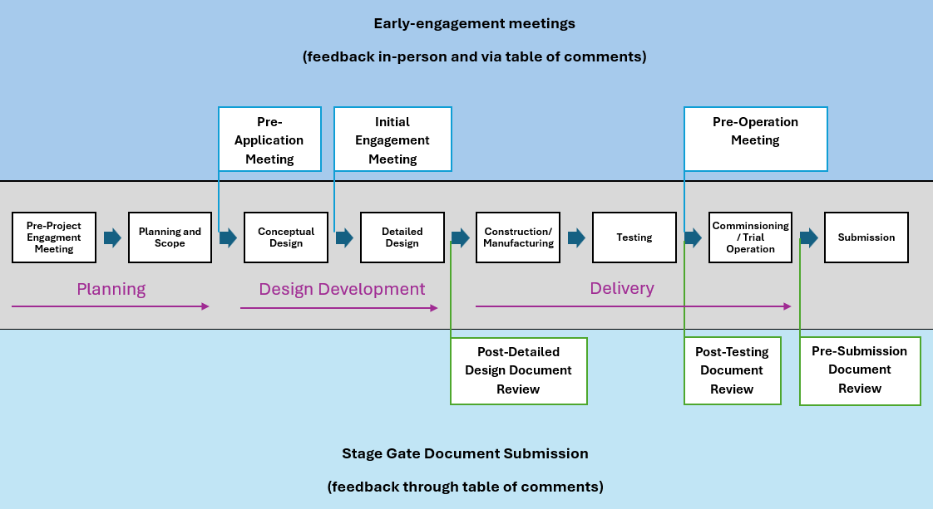

Stage Gate Reviews – Upgraded or Renewed Subsystems

  - The engagement timeline, meetings and document submissions, for upgrades and renewals of Structural Subsystems is set out in Figure 3.3. The Applicant should take part in two formal engagement meetings at the following points in the project or programme:

- Initial Engagement Meeting: after Conceptual Design

- Pre-Operation Meeting: before Commissioning/Trial Operation

  - Where the Structural Subsystem is subject to an upgrade or renewal, Applicants are encouraged to produce two interim document submissions at the following points in the project or programme:

- Pre-Testing Review: after Modification Application, before Testing
- Pre-Submission Review: at least three months before the final document submission

Figure 3.3 Engagement Timeline for Upgrades & Renewals

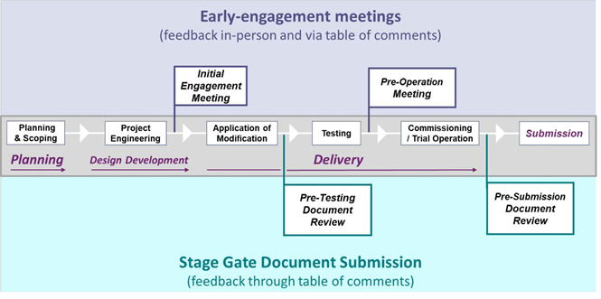

Assessment of major projects

  - To assess whether a project qualifies as major for the purposes of interoperability authorisation under Directive (EU) 2016/797, the following criteria should be considered:

- Subsystem Impact: if the project involves the upgrade or renewal of a Structural Subsystem such as Infrastructure, Rolling Stock, Energy, or Control-Command and Signalling

- Essential Requirements: whether the project affects compliance with essential requirements including safety, reliability, health, environmental protection, technical compatibility, and accessibility

- TSI Applicability: whether the project requires conformity with one or more TSIs, any Open Points, Specific Cases, or cases where TSIs do not apply

- Cross-Border Relevance: if the Subsystem will operate or interface cross-border, requiring coordination with ERA

- Risk and Complexity: the technical complexity and novelty of the project, and whether it requires a CSM-RA and appointment of an AsBo.

- Scale and Investment: the scale of the project and the level of financial investment or strategic importance

  - Applicants’ early engagement with the Department is recommended. To determine whether an authorisation is required in the case of the renewal or upgrading of:

(a) fixed installations, the Department will consider factors including -

- the extent to which the overall safety level of the fixed installation concerned may be adversely affected by the works envisaged

- whether the new authorisation is required by the TSIs

- any relevant requirements of the National Implementation Plan (NIP)

- any changes made to the values of the parameters on the basis of which the authorisation was already granted

or (b) vehicles if -
- changes are made to the values of the parameters which are outside the range of acceptable parameters as defined in the TSIs and, where applicable, in notified NRs, for checking the technical compatibility between the vehicle and the area of use

- the overall safety level of the vehicle concerned may be adversely affected by the works envisaged, or

- it is required by the relevant TSIs.
Note: Applications for domestic and cross-border vehicle authorisations are submitted via the European Union Agency for Railways (ERA) One-Stop-Shop (OSS).

Technical File submission and approval

  - The Applicant should ensure that their application is supported by sufficient evidence before submission to the Department. This means applications should include at least the following items:

- a file setting out details of the project, including a presentation of technical descriptions, technical drawings, test methods and results, simulations, calculations, and operation and maintenance requirements

- identification of any TSI, or part of a TSI, and any cases where TSIs should not apply (and associated Conditions where applicable) or non-application of TSIs

- an assessment of whether there are any new or changed safety risks
resulting from the works envisaged and how any such risks will be managed

- reports from the third-party assessors should support that issues raised have been addressed

- ‘EC’ Declarations of Verification

  - All submitted documents should be written in English and should be submitted in standard file formats, such as Microsoft Word or PDF format, on A4 size paper.
  - The Applicant should submit a statement that all identified hazards and associated risks are controlled and will continue to be monitored after approval, with a strategy for doing so. Where applicable, this should acknowledge requirements from other regulations (see CSM-RA Regulation 16).

  - To ensure that the Subsystem can be placed into service in line with project or programme timescales, the Applicant should allow sufficient time in the project schedule for evaluation by third-party assessors and at least one month for the Department's review during final submission.

  - After receiving the formal application, the Department will inform the Applicant as soon as possible about whether they consider the application to be incomplete. If an application is incomplete, the Department will request supplementary information, along with a reasonable deadline for its provision.

  - The time it takes for the Department to review submissions will depend on the effectiveness of early engagement, the quality of the original submission, novelty, scale and complexity of the system, and the associated requirements to prove that compliance with safety requirements and risk control has been maintained.

Note: The Applicant should develop a process to escalate and resolve any changes to project schedules that impact the review time for the Notified Body (NoBo)/AsBo/Designated Body (DeBo)/Department. We recommend the following rating system:

“Green” All reviews will start in line with the planned schedule

“Amber” NoBo/DeBo/AsBo/Department reviews will start later than planned, but durations remain the same.

“Red” The duration for NoBo/DeBo/AsBo/Department reviews shortens OR the gap between NoBo/DeBo/AsBo/Department reviews is removed completely OR the gap between the Department’s review and APIS is removed completely.

Approach to Authorisation

This chapter sets out the Approach to Authorisation that Applicants should follow under specific circumstances. It describes:

- assessing the change under CSM-RA

- authorisations for Fixed Infrastructure

- authorisations for Rolling Stock

- authorisations for Control-Command and Signalling

- authorisations for Large Packages of Work

- interfaces between systems

Assessment of the change

4.1. To determine the appropriate approach, the Applicant should consider the:

- importance of the change

- category of work to which the project belongs

  - Choosing the right approach is important because the process differs depending on the type of project envisaged, such as whether it is an Infrastructure or Rolling Stock Subsystem, or the type of change envisaged such as new equipment, or changes to existing equipment.

  - In the case of new rolling stock, a new Authorisation for Placing on the Market (APOM) will be required and similarly, for new fixed infrastructure an APIS is required. In the case of an upgrade or renewal of rolling stock a new APOM may be required, and the Applicant should consult the authorising entity for their view on whether an authorisation is required. In the case of an upgrade or renewal of fixed infrastructure the Applicant should apply to the Department for a decision on whether an authorisation is required.

  - To determine the importance of the change the Applicant should consider the impact of the proposed change on safety. For guidance on what constitutes a Significant change Applicants should refer to Article 4 of CSM-RA.

  - Where the change is not Significant then it is recommended that the CSM-RA risk management process is applied, as described in Article 2 of CSM-RA.

  - The creation of any new Subsystem that requires an interoperability authorisation will likely have an impact on safety and will usually (though not in all cases) be considered to be Significant.

  - The flowchart in Figure 4.1, in addition to criteria delineated within Article 4 of the CSM-RA regulation, should be used to determine the significance of the change to assess whether the CSM-RA applies to the project or programme.

Figure 4.1 Significance of a change

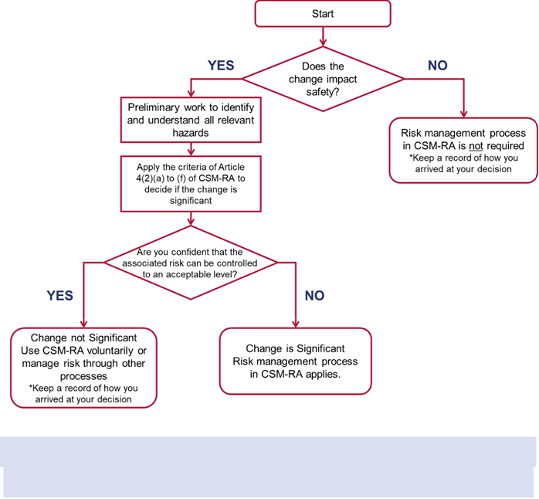

Note: In the case of organisational changes, only those likely to have an impact on the operation or maintenance activities should be considered.

Authorisations for Fixed Infrastructure

  - Fixed Infrastructure authorisations fall into three categories:

- New Infrastructure – commissioning of a new Subsystem in the absence of a pre-existing Subsystem

- Upgrade – any work on a Subsystem or part of it which results in a change in the Technical File accompanying the ‘EC’ Declaration of Verification, if that Technical File exists, and which improves the overall performance of the Subsystem

- Renewal – any substitution work on a Structural Subsystem (or part of a Structural Subsystem) which does not change the overall performance of the Structural Subsystem

  - For Infrastructure designed to earlier TSI standards, the Applicant should consult the Department for guidance. The Department will provide guidance on authorisation in these cases on an ad-hoc basis, taking into account relevant Health and Safety legislation.

  - For ‘New Infrastructure’ and upgrades and renewals’ authorisations, the Applicant should follow the submission content structure set out in Appendix D.

  - In the case of maintenance and removals, an application for authorisation is not required and the Applicant should take any reasonable opportunity to meet current standards in accordance with their own standards and processes.

Authorisations for Rolling Stock

  - The Applicant should consider additional factors for Rolling Stock authorisations that depend on the circumstances of their project or programme.

  - Rolling Stock authorisations fall into three broad categories:

  - New Rolling Stock - Rolling Stock that is not authorised for the NI railway and does not have a valid authorisation under the EU TSI regulations

  - Existing Rolling Stock - Rolling Stock that is not authorised for the NI railway but has valid authorisation under the EU TSI regulations

  - Upgraded Rolling Stock - Rolling Stock that may or may not be already authorised for the NI railway and is upgraded and brings it into scope.

  - Cross-border authorisation for Rolling Stock

Applications for new Rolling Stock that crosses the border into another Member State and extends the Area of Use must apply for authorisation directly via the One-Stop-Shop (OSS) to the European Union Agency for Railways (ERA), which acts as the authorising entity in this situation. The Department will continue its role as the National Safety Authority, conducting assessments to identify risks and making recommendations for any areas of concern that may directly affect the NI railway network.

  - For all categories of Rolling Stock, the Applicant should follow the content structure set out in Appendix D.

  - For existing Rolling Stock, the Applicant should focus on reviewing the published data for that Rolling Stock and if there were any deviations from the TSIs and NRs. This includes:

- a copy of the APOM
- where applicable, maintenance history of the Subsystem and any technical modifications made since authorisation was granted

  - For upgraded Rolling Stock, the Applicant should focus on the impact of the modifications and how safety and compliance with TSIs and NRs will be maintained. This includes:

- clear definition of the scope of modification, including any changes to interfaces with other Subsystems

- description of intent to the modification

- description of the functional and technical elements affected by the modification

  - For Rolling Stock designed to earlier standards, the Applicant should consult the Department for guidance. The Department will provide guidance on authorisation in these cases on an ad-hoc basis, taking into account relevant health and safety legislation.

Authorisations for Control-Command and Signalling

  - Projects involving Control-Command and Signalling Subsystems must consider compliance with the European Rail Traffic Management System (ERTMS), which comprises:

- ETCS (European Train Control System): the automatic signalling and train control protection system that ensures speed and distance safety.

- GSM-R (Global System for Mobile Communications – Railway): the radio communication system for managing voice and data between trackside and onboard equipment.

- FRMCS (Future Railway Mobile Communication System): the next-generation communication system and successor to GSM-R that will be implemented as the mobile radio component of the ERTMS framework for the digitalization of railway mobile radio systems, based on 5G technology, to provide higher data rates and low latency for advanced train control, safety systems, and new applications.

  - Applicants must:

- demonstrate compatibility with existing ERTMS infrastructure

- address any Open Points or Specific Cases in the TSIs

- engage with ERA for cross-border authorisations involving ERTMS

  - Where ERTMS is implemented or upgraded, the Applicant must include:

- ETCS baseline version and compatibility details

- GSM-R/FRMCS frequency and interoperability parameters

- Safety integration evidence via CSM-RA and AsBo assessment

Large packages of work

  - Projects or programmes of work that are used to deliver Large Packages of Work in multiple discrete phases, may sometimes be treated as a single Structural Subsystem to avoid multiple authorisations being required.

  - Applicants who wish to combine multiple projects or programmes together under one authorisation application must consult the Department before following this approach to ensure that it is a suitable course of action. Applicants should also make it clear with the Department during the Initial Engagement Meeting that they wish the project/program of work to be regarded as a single Subsystem.

  - An Applicant wishing to group packages of work together should focus on what makes up the Structural Subsystem within the context of the particular project or programme of work.

  - When following this approach, a judgement will need to be made as to what constitutes the Structural Subsystem in each stage of work by taking into account the wider context.

  - In assessing an Applicant’s proposal, the Department will consider whether each package of work within a project or programme of work is:

  - a Structural Subsystem in its own right, in which case each package of work will require an authorisation at the point it is placed in service and put into use; or

  - a component part of the Structural Subsystem, in which case an authorisation can be obtained (as determined by the Department) either upon completion of key milestones, or at the point the upgrade or renewal of that Structural Subsystem has been completed in its entirety

  - The Department will confirm in writing if approach (b) can be used by the project and will agree with the Applicant how many authorisations will be required and at what point they must be obtained.

  - Where the Department agrees this approach is appropriate, the Applicant will need to comply with such requirements as the Department determines is necessary.

Interfaces Between Systems

  - The nature of the modern railway network is that Subsystems are highly interconnected and will often impact on other Subsystems already in operation. This is particularly notable where there are Large Packages of Work comprised of multiple Subsystems.

  - The interfaces between Subsystems are not the subject of a separate authorisation but should be considered in the authorisation application for a Subsystem.

  - The Applicant should identify how the changes in interfaces due to the introduction of the new Subsystems impact on safety and operability as part of their project design and risk management processes.

  - The Applicant should make a record of any “cross-interface risks” that the introduction of the new Subsystem could lead to and ensure that these are addressed as part of their authorisation application.
  - For examining the interface, the general safety demonstration principles in Appendix D remain the same.

Regulatory Environment

This section of the guidance sets out the main regulatory requirements placed on Applicants under the interoperability Regulations, RINIR 2026. It describes:

- Regulations applicable to interoperability

- the role of the CSM-RA in interoperability

- the role of conformity assessment bodies

- expectations of Applicants

Interoperability Regulations

5.1 The TSIs are EU standards defining the technical and operational standards that must be met by each Subsystem in order to meet the essential requirements specified in RINIR 2026 and ensure the interoperability of the railway system.

  - The various TSIs apply to specific ‘Structural’ Subsystems such as Infrastructure and Rolling Stock, to functions such as Operations and Telematics, across a number of Subsystems such as the TSIs for accessibility for Persons with Reduced Mobility (PRM) or define requirements for conformity assessment.

  - Applicants should identify TSIs that are specific to their process and use the applicable version with correct amendments of the TSIs.

  - If a project or programme of work is at an advanced stage of development and a relevant TSI is updated, then the Applicant should assess the impact of complying with the revised TSI. Where the impact is Significant as per CSM-RA then they should consult the Department as the Competent Authority for guidance.

  - To submit a valid application for authorisation an Applicant must:

- engage a NoBo to carry out the ‘EU’ verification assessment procedure

- ensure that a NoBo continues to be engaged throughout the project once appointed

- engage a Designated Body (DeBo), to perform an assessment of verification against NRs. If no NRs are applicable to the project, then this does not apply

Note: Applicants should ensure adequate interoperability expertise is maintained throughout the project. The amount of expertise needed will vary across the project lifecycle and Applicants should consider where they will obtain expertise from at each project stage. This could either be within the project team or through external subject matter experts.

  - The Applicant or manufacturer must draw up an ‘EC’ Declaration of Verification in relation to the project Subsystem that complies with Annex IV of Directive (EU) 2016/797, a summary of which can be found in Appendix E.

  - NRs provide controls in addition to TSIs to ensure that the essential requirements specified in RINIR 2026 are met.
  - NRs are provided in situations to fill Open Points in TSIs, support Specific Cases in TSIs, and to set out the requirements to maintain technical compatibility between assets that do not conform to the requirements of TSIs.

  - In this context Open Points are defined as technical aspects corresponding to the essential requirements that are not explicitly covered in the TSI.

  - Derogations from NRs, in exceptional cases, are analysed by the Department and cases where TSIs do not apply are analysed by ERA on a case-by-case basis.

  - Applicants are encouraged to develop a measure of TSI compliance risk, to be updated periodically and reported to the Department. This measure should consider factors such as, a) number of issues raised by the NoBo and the DeBo, b) contingency in schedule for the Department’s review (we recommend this risk measure is reported as a red/amber/green (RAG) status for ease of use).

The role of CSM-RA in Interoperability

  - The Applicant must ensure that risks associated with the technical, operational or organisational change associated with the introduction of the new or changed Subsystem are evaluated and assessed as part of their risk assessment and management processes.

  - Any technical, operational or organisational change must be assessed as to whether or not it is a Significant change under the CSM-RA as described in Paragraph 4.4.

  - The risk management process described in CSM-RA is an iterative process for managing risk and is based on four stages (see point 1.1.1. of Annex I of CSM-RA):

- definition of the system under assessment

- systematic hazard identification, covering identification of:

  - the hazards
  - the risks
  - the associated safety measures
    - the resulting safety controls which must be met by the system under assessment

- demonstration of the system's compliance with the safety requirements

- management of all identified hazards and associated safety measures

  - The Applicant should document and implement appropriate controls in accordance with the risk acceptance criteria outlined in CSM-RA, which is to implement suitable safety requirements so as to reduce the risk ‘so far as is reasonably practicable’ (SFAIRP)

  - Risks can only be considered SFAIRP when all possible risk reduction options have been evaluated in one or more of the following ways:

- the application of recognised industry good practice standards

- comparison with one or more reference systems
- explicit risk estimation (qualitative and/or quantitative)

  - For projects subject to CSM-RA, where the change is deemed to be Significant, the Applicant must also appoint an AsBo to independently assess their risk management processes.

  - The Applicant must produce a written declaration indicating that relevant hazards have been identified and that associated risks are controlled to an acceptable level (see Article 16 of CSM-RA).

  - The risk management process must be traceable throughout the design, construction and operation of the project, and Applicants must maintain a hazard record throughout the system’s life after being granted authorisation.

The role of conformity assessment bodies

  - Applicants should appoint competent organisations to perform activities of conformity assessment. This includes appointment of an AsBo for Significant changes, as well as a DeBo and a NoBo.

Assessment Body (AsBo)

  - The AsBo makes an assessment of compliance with CSM-RA (where change is Significant). The AsBo:

- produces a SAR in accordance with the requirements of Annex III of the CSM-RA

- reports on compliance, which can be either ‘supportive’ or ‘non-supportive’. A non-supportive SAR is essentially a rejection of the application in which case the Applicant must provide justification and documentation to close-out any remaining non-compliances with CSM-RA

- the Applicant should address recommendations and ask the AsBo to update their response accordingly

Notified Body (NoBo)

  - NoBos are designated under EU legislation and assess conformity against EU TSIs. These apply in Northern Ireland under the Windsor Framework. In Northern Ireland, NoBos remain the relevant authority for TSI conformity assessments. They provide independent certification at specific stages in the project lifecycle as to whether a Structural Subsystem conforms to required TSIs. The NoBo:

- produces a Certificate of Verification (CoV) that references the TSIs against which conformity has been assessed

- can optionally produce Intermediate Statements of Verification (ISVs) that reference TSIs against which the conformity of parts of a Subsystem or various project stages has been examined.

Designated Body (DeBo)

  - DeBo assesses compliance with NRs. The DeBo:

- produces a CoV that references the NRs whose conformity has been examined

- can optionally produce ISVs at the design and/or production stages

- report should not cover aspects falling within the NoBo’s area of competence

  - The Applicant should produce an ‘EC’ Declaration of Conformity or suitability for use and an ‘EC’ Declaration of Verification to submit as part of the Technical File.

Figure 5.1 The roles and duties of independent assessors

Produces Intermediate Statements of Verification (ISV) and EC Certificate of Verification (CoV)
Produces Intermediate Statements of Verification (ISV) and UK Certificate of Verification (CoV)
Applicant requires third party verification

Assessment Body (AsBo)
(Paragraph 5.21)
Notified Body (NoBo)
(Paragraph 5.22)
Designated Body (DeBo)
(Paragraph 5.23)

Assessments result in the following being issued to the Applicant

Produces safety Assessment Report (SAR)

Applicant produces EC Declaration of Conformity and EC Declaration of Verification

The Applicant should submit all documentation to the Department as part of the complete Technical File to obtain authorisation

  - To avoid recommendations or Conditions being carried forward to the next stage of review, the Applicant should allow sufficient time between review and beginning the next stage to find solutions to issues and close them out accordingly. Also see ‘Note’ at paragraph 3.39.

  - Applicants should focus on obtaining tangible evidence to solve Conditions and recommendations that conformity assessment bodies provide, rather than focusing on finding a form of words to satisfy assessors that issues have been resolved.

  - Independent assessors can raise queries or recommend good practices to Applicants throughout the process; Applicants should consider these and seek to understand the reasons behind them before accepting or rejecting them.

Note: The Applicant should develop a dated and resourced plan in the event of non-supportive NoBo/DeBo assessment. This plan should set out how the Applicant will obtain a supporting assessment. For example, it could include:

- process map for obtaining evidence to close out issues

- methodology for contacting other project teams which dealt with similar issues

- list of contacts for specialists who may be required to close out Conditions and recommendations

Expectations of Applicants

  - Applicants are responsible for planning, managing, monitoring and coordinating health and safety on their worksites. They must also ensure that the system can be operated and maintained to prevent (SFAIRP) danger to the public, employees’ subcontractors and third parties.

  - The Applicant is responsible for defining the scope of assessment for all conformity assessment bodies. Applicants must ensure each body has its own field of competence and that their responsibilities do not overlap.

  - Applicants should promptly inform the Department in the following events:

- the scope of the project, project stages, or approach to authorisation changes

- the Applicant considers it can no longer meet the requirements set out in the authorisation plan

- the standard of the completed works could impact on the overall safety of the Subsystem or the wider rail network

  - Any of these circumstances could result in the Department requiring an Applicant to obtain additional authorisations upon completion of individual packages of work or upon completion of agreed milestones or agree changes to the authorisation plan.

  - The Department may also request specific assurances from the Applicant that risks have been identified and are being managed appropriately.

Glossary & Definitions

TERM | DEFINITION
Applicant | A natural or legal person requesting an authorisation, be it a railway undertaking, an infrastructure manager or any other person or legal entity, such as a manufacturer, an owner or a keeper, to place new, upgraded, or renewed railway subsystems, infrastructure, or rolling stock into use.
Assessment Body (AsBo) | An independent body that assesses the applicant’s risk management process under the CSM-RA when a change is Significant, issuing a Safety Assessment Report (SAR).
Authorisation for Placing in Service (APIS) | All operations by which a subsystem is put into its design operating state. Authorisation is required before it can be put into use.
Certificate of Verification (CoV) | A formal document produced by a Notified/Approved Body confirming that a railway subsystem has been assessed through the relevant verification procedures and meets the applicable EU interoperability requirements and any relevant National Rules.
Common Safety Method on Risk Evaluation and Assessment (CSM-RA) | EU method defining how to determine significance of changes, identify hazards, evaluate/accept risk, and demonstrate safe integration for railway changes.
Competent Authority | The Department for Infrastructure established by Article 3(1) of the Departments (Northern Ireland) Order 1999(c) and renamed by section 1(6) of the Departments Act (Northern Ireland) 2016.
Conditions | Specific restrictions, limitations, or requirements imposed by a Competent Authority when authorising the placing in service of a structural subsystem (e.g., new rolling stock or infrastructure).
Conformity Assessment Body (CAB) | A body that has been notified or designated to be responsible for conformity assessment activities, including calibration, testing, certification and inspection; a conformity assessment body is classified as a ‘notified body’ following notification by a Member State; a conformity assessment body is classified as a ‘designated body’ following designation by a Member State
Designated Body (DeBo) | A conformity assessment body is classified as a ‘designated body’ following designation by a Member State. A body designated to assess conformity against National Rules (where TSIs have open points, specific cases, or local compatibility needs) and issue ISVs/CoVs accordingly.
‘EC’ Certificate of Verification (CoV) | A certificate drawn up by an EU Notified Body or  an NI Notified Body as part of the EC verification assessment procedure for a structural subsystem.
‘EC’ Declaration of Conformity or suitability for use (DoC) | A declaration drawn up in accordance with regulation 29 or in accordance with Articles 9 and 10 of Directive (EU) 2016/797.
‘EC’ Declaration of Verification (DoV) | A declaration drawn up in accordance with regulation  20 or in accordance with Article 15 of Directive (EU) 2016/797.
European Rail Traffic Management System (ERTMS) | Established in accordance with the characteristics set out in Directive 96/48/EC of 23 July 1996 on the interoperability of the trans-European high-speed rail system.
European Train Control System (ETCS) | The automatic signalling and train control protection system that ensures speed and distance safety
Future Railway Mobile Communication System (FRMCS) | The next-generation communication system and successor to GSM-R that will be implemented as the mobile radio component of the ERTMS framework for the digitalization of railway mobile radio systems, based on 5G technology, to provide higher data rates and low latency for advanced train control, safety systems, and new applications.
Global System for Mobile Communications – Railway (GSM-R) | The radio communication system for managing voice and data between trackside and onboard equipment.
Intermediate Statement of Verification (ISV) | A statement issued by a NoBo/DeBo confirming compliance of defined parts or stages of a subsystem; multiple ISVs can be integrated into the final verification. [union-rail.com], [groupe-sncf.com]
National Rule (NR) | All binding rules adopted in a Member State, irrespective of the body issuing them, which contain railway safety or technical requirements, other than those laid down by European Union or international rules which are applicable within that Member State to railway undertakings, infrastructure managers or third parties.
National Safety Authority | The Department for Infrastructure
(EU) Notified Body (NoBo) | A conformity assessment body is classified as a ‘notified body’ following notification to the European Commission by a Member State in accordance with Chapter VI of Directive (EU) 2016/797, unless its appointment has been terminated or its notification has been withdrawn, that performs conformity assessment against TSIs and issues ISVs/CoVs for subsystems.
Open Point | A technical aspect relating to the essential requirements that is not explicitly covered by the technical specification for interoperability (TSI). It represents a part of the standard that is not yet fully defined or agreed upon, meaning interoperability cannot be fully guaranteed in that specific area.
Put into use | The first operational use of a subsystem on (or as part of) the rail system after construction, upgrade, or renewal.
Safety Assessment Report (SAR) | The AsBo’s report concluding whether the system under assessment complies with CSM-RA; a supportive SAR underpins authorisation.
Significant | The criteria for assessing whether a change is significant or not is set out in EU Regulation 402/2013 Article 4: failure consequence, novelty, complexity, monitoring, reversibility and additionality.
Specific Case | Any part of the rail system which needs special provisions in the TSIs, either temporary or permanent, because of geographical, topographical or urban environment constraints or those affecting compatibility with the existing system, in particular railway lines and networks isolated from the rest of the Union, the loading gauge, the track gauge or space between the tracks and vehicles strictly intended for local, regional or historical use, as well as vehicles originating from or destined for third countries.
Structural Subsystem | A structural or functional part of the rail system. as specified in paragraph 1(a) of Annex II to Directive (EU) 2016/797, that must meet essential requirements; structural subsystems include Infrastructure, Energy, Control-Command & Signalling (trackside/onboard) and Rolling Stock.
Technical File | The body of evidence (designs, test results, assessments, certificates, declarations, etc.) demonstrating conformity and forming the basis for authorisation.
Technical Specification for Interoperability (TSI) | A specification for interoperability adopted in accordance with Directive (EU) 2016/797 by which each subsystem or part of a subsystem is covered in order to meet the essential requirements and ensure the interoperability of the Union rail system.

Appendix A: General Information about Interoperability

Directive 2008/57/EC on the interoperability of the rail system within the European Community (the Interoperability Directive), and associated regulations (The “Interoperability Regulations”), set out the conditions required to achieve interoperability. Directive 2008/57/EC was transposed into UK law through the Railways (Interoperability) Regulations 2011 (RIR 2011).

Directive 2008/57/EC was superseded by Directive (EU) 2016/797 and transposed into UK law through the Railways (Interoperability) (Amendment) (EU Exit) Regulations 2019, (EU Exit SI) which amended RIR 2011.

The EUs’ rail interoperability framework ((EU) 2016/797) continues to apply in NI by virtue of Annex II of the Northern Ireland Protocol (NIP). As the EU Exit SI was made prior to the agreement of the NIP and written to apply UK-wide, it is inconsistent with some of the Protocol’s requirements. Until RINIR 2026 was introduced to make the legislation compliant with commitments under the NIP, RIR 2011 applied in NI.

The UK’s Secretary of State for Transport published a NTSN for Northern Ireland. This NTSN states that EU TSIs are applicable in Northern Ireland under the Windsor Framework and provided a legal basis for the continued application of RIR 2011 in Northern Ireland whilst RINIR 2026 implementing Directive (EU) 2016/797 was awaited.

The purpose of interoperability is to ensure technical compatibility of trains and Infrastructure across the EU and establish common standards and assessment processes for new, upgraded or renewed rail vehicles, Infrastructure and components such that they meet the Essential Requirements for interoperability. These Essential Requirements include safety, reliability, accessibility and environmental protection.

The standardisation of Structural Subsystems (such as Rolling Stock and Infrastructure) removes barriers to trade, delivering benefits through economies of scale and enables the costs of the railway to be reduced. The benefits provided by interoperability enable the rail sector to compete more effectively with other transport modes.

Under RINIR 2026, Structural Subsystems must obtain an interoperability authorisation for the Placing in Service or Placing on the Market before being put into use for the purpose for which they were designed or as part of the NI rail system.

An interoperability authorisation provides confirmation that new, upgraded or renewed Structural Subsystems or vehicles meet the essential requirements for interoperability and comply with the relevant applicable legal requirements, including TSIs, Common Safety Methods (CSMs) and NRs.

New, upgraded and renewed Structural Subsystems are subject to conformity assessment body verification and assessment procedures. These assessments assist the Department in determining whether requirements for interoperability have been met.

Appendix B: Structure for Early Engagement for New Subsystems

Timings |  |  | 1. | Pre-Application: 1 meeting before conceptual design
 |  |  | 2. | Initial Engagement: 1 meeting before detailed design
 |  |  | 3. | Pre-Operation: 1 meeting before commissioning/trial operation
Attendees |  |  | ■ | The Department: Assigned lead for this project;
 |  |  | ■ | Applicant: Project Manager/Director; Project Sponsor; Subject experts from project team;
 |  |  | ■ | NoBo/DeBo: Optional, but recommended
Suggested Agenda Items
Meeting |  |  |  | Clarifications |  |  | Project Definition |  |  |  | Project Status
1: Pre-Application |  |  | ■ | Clarify roles and responsibilities of |  | ■ | System Definition: including scope |  |  | ■ | Request for authorisation
 |  |  |  | Applicant, assessors, the Department |  |  | and purpose, maps/plans, interfaces, |  |  | ■ | Confirm ‘significance’ of change
 |  |  | ■ | Manage expectations for initial |  |  | possible future benefits, technical and |  |  |  | and type of authorisation
 |  |  | ■ | Manage expectations for initial |  |  | functional characteristics of the |  |  |  | and type of authorisation
 |  |  |  | engagement meeting |  |  | functional characteristics of the |  |  | ■ | Risks & Issues log – showing path
 |  |  |  | engagement meeting |  |  | Subsystem and its interfaces |  |  | ■ | Risks & Issues log – showing path
 |  |  |  | Clarify “what good looks like”, e.g. |  |  | Subsystem and its interfaces |  |  | ■ | Risks & Issues log – showing path
 |  |  | ■ | Clarify “what good looks like”, e.g. |  | ■ | Project authorisation strategy: |  |  |  | to obtain evidence of compliance for
 |  |  |  | complete Technical File and no |  | ■ | Project authorisation strategy: |  |  |  | each item
 |  |  |  | complete Technical File and no |  |  | Present preliminary schedule, |  |  |  | each item
 |  |  |  | Conditions on authorisation |  |  | Present preliminary schedule,
 |  |  |  | Conditions on authorisation |  |  | planned commissioning date
 |  |  | ■ | Confirm Applicant has access to |  |  | planned commissioning date
 |  |  | ■ | Confirm Applicant has access to |  | ■ | Preliminary feasibility study and
 |  |  |  | TSI expertise and has a method of |  | ■ | Preliminary feasibility study and
 |  |  |  | assessing TSI compliance risk |  |  | preliminary safety impact analysis
 |  |  | ■ | Confirm Applicant is aware of self-
 |  |  |  | assessment checklist/Stage Gate
 |  |  |  | intervals

 | Meeting |  |  |  | Clarifications |  |  | Project Definition |  |  |  | Project Status
 | 2: Initial Engagement |  |  | ■ | Clarify contingency plans (in case of non-supportive SARs) |  | ■ | List applicable legislation (TSIs, |  |  | ■ | Review project TSI RAG status
 |  |  |  |  |  |  |  | any NRs, any other Codes of |  |  | ■ | Discussion of open third-party
 |  |  |  |  |  |  |  | Practice, etc.) |  |  | ■ | Discussion of open third-party
 |  |  |  | ■ | Clarify document control strategy |  |  | Practice, etc.) |  |  |  | assessor queries and
 |  |  |  | ■ | Clarify document control strategy |  |  | Timelines, critical path activities, key |  |  |  | assessor queries and
 |  |  |  | ■ | Manage expectations for post- |  | ■ | Timelines, critical path activities, key |  |  |  | recommendations
 |  |  |  | ■ | Manage expectations for post- |  |  | milestones (including NoBo
 |  |  |  |  | detailed design report |  |  | milestones (including NoBo |  |  | ■ | Discuss supplier competence and
 |  |  |  |  | detailed design report |  |  | /DeBo timelines) |  |  | ■ | Discuss supplier competence and
 |  |  |  |  |  |  |  | /DeBo timelines) |  |  |  | contracts (check TSI evidence is
 |  |  |  |  |  |  |  | Staging of authorisation, ISVs, |  |  |  | contracts (check TSI evidence is
 |  |  |  |  |  |  | ■ | Staging of authorisation, ISVs, |  |  |  | being provided)
 |  |  |  |  |  |  |  | Derogations, and possible tests |  |  | ■ | Risks & issues log
 | 3: Pre-Operation |  |  | ■ | Clarify activities to monitor |  | ■ | Discuss Operations & Maintenance |  |  | ■ | Review project TSI status e.g.
 |  |  |  |  | compliance |  |  | strategy after handover |  |  |  | RAG
 |  |  |  | ■ | Clarify contingency plans (in case of non-supportive SARs) |  | ■ | Discuss change management |  |  | ■ | Discussion of open third-party
 |  |  |  |  |  |  |  | process and anticipated changes |  |  |  | assessor queries and
 |  |  |  |  |  |  |  |  |  |  |  | recommendations
 | Minutes of meeting are taken to ensure that there is a shared understanding of what was discussed and agreed
 | Things to avoid at the  meeting |  |  | ■ | Presenting only ‘good news’ or optimistic views of risks. The aim of these meetings is to discuss problem areas and find a way  forward – not just to reassure either party.
 | Things to avoid at the  meeting |  |  | ■ | The assumption that “it’s too early to discuss the details” at Initial Engagement. While technical components might not be finalised, the staging and relevant TSI clauses must be understood in detail.
 | The Department to review before |  |  | ■ | The Department’s Authorisation leads to check for any concerns about the project
 | meetings |  |  | ■ | The Department’s Authorisation leads to review internal lessons learned from previous authorisations of similar projects (e.g. new station PRM, new OLE etc.)

Appendix C: Structure for Early Engagement for Upgrades & Renewals

 |  | Timings |  |  | 1. | Initial Engagement: 1 meeting before application of modification
 |  |  |  |  | 2. | Pre-Operation: 1 meeting before commissioning/trial operation
 |  | Attendees |  |  | ■ | The Department: Assigned lead for this project;
 |  |  |  |  | ■ | Applicant: Project Manager/Director; Project Sponsor; Subject experts from project team;
 |  |  |  |  | ■ | NoBo/DeBo: Optional, but recommended
 |  | Suggested Agenda Items
 |  | Meeting |  |  |  | Clarifications |  |  | Project Definition |  |  |  |  | Project Status
 |  | 1: Initial |  |  | ■ | Clarify roles and responsibilities of |  | ■ | System Definition: including scope |  |  |  | ■ | Request for authorisation
 |  | Engagement |  |  |  | Applicant, assessors, the Department |  |  | and purpose, maps/plans, interfaces, |  |  |  | ■ | Confirm ‘significance’ of
 |  |  |  |  | ■ | Manage expectations for initial engagement |  |  | possible future benefits, technical and |  |  |  |  | change and type of
 |  |  |  |  | ■ | Clarify “what good looks like”, e.g. complete |  |  | functional characteristics of the |  |  |  |  | authorisation
 |  |  |  |  |  | Technical File and no Conditions on authorisation |  |  | Subsystem and its interfaces |  |  |  | ■ | Risks & Issues log – showing
 |  |  |  |  |  | Technical File and no Conditions on authorisation |  | ■ | Project authorisation strategy: |  |  |  | ■ | Risks & Issues log – showing
 |  |  |  |  | ■ | Confirm Applicant has access to TSI expertise |  | ■ | Project authorisation strategy: |  |  |  |  | path to obtain evidence of
 |  |  |  |  |  | and a method of assessing TSI compliance risk |  |  | Present preliminary schedule, |  |  |  |  | compliance for each item
 |  |  |  |  | ■ | Confirm Document Control Strategy |  |  | planned commissioning date |  |  |  | ■ | Discussion of open third-party
 |  |  |  |  | ■ | Confirm Document Control Strategy |  | ■ | Staging of authorisation, ISVs, |  |  |  | ■ | Discussion of open third-party
 |  |  |  |  | ■ | Clarify contingency plans (in case of non- |  | ■ | Staging of authorisation, ISVs, |  |  |  |  | assessor queries and
 |  |  |  |  | ■ | Clarify contingency plans (in case of non- |  |  | cases where TSIs do not apply, non-application of TSIs, and possible tests |  |  |  |  | Recommendations
 |  |  |  |  |  | supportive SARs) |  |  |  |  |  |  |  | Recommendations
 |  |  |  |  |  | supportive SARs) |  | ■ | List applicable legislation (TSIs, |  |  |  | ■ | Review project TSI RAG
 |  |  |  |  | ■ | Clarify document control strategy |  | ■ | List applicable legislation (TSIs, |  |  |  | ■ | Review project TSI RAG
 |  |  |  |  | ■ | Clarify document control strategy |  |  | any NRs, any other Codes of |  |  |  |  | Status
 |  |  |  |  | ■ | Manage expectations for post-detailed design Report |  |  | any NRs, any other Codes of |  |  |  |  | Status
 |  |  |  |  | ■ | Manage expectations for post-detailed design Report |  |  | Practice, etc.) |  |  |  | ■ | Discuss supplier competence and contracts (check TSI evidence is being provided)
 |  |  |  |  | ■ | Confirm Applicant is aware of self-assessment checklist and Stage Gate intervals |  | ■ | Timelines, critical path activities, key milestones (including NoBo/DeBo timelines) |  |  |  | ■

Meeting |  |  |  | Clarifications |  |  |  | Project Definition |  |  |  |  | Project Status
2: Pre- |  |  | ■ | Clarify activities to monitor compliance |  |  | ■ | Discuss Operations & Maintenance |  |  |  | ■ | Review project TSI status
Operation |  |  | ■ | Clarify contingency plans (in case of non- |  |  |  | strategy after handover |  |  |  |  | e.g. RAG
 |  |  | ■ | Clarify contingency plans (in case of non- |  |  |  | Discuss change management |  |  |  |  | Discussion of open third-party
 |  |  |  | supportive SARs) |  |  | ■ | Discuss change management |  |  |  | ■ | Discussion of open third-party
 |  |  |  |  |  |  |  | process and anticipated changes |  |  |  |  | assessor queries and
 |  |  |  |  |  |  |  |  |  |  |  |  | Recommendations
Minutes of meeting are written to ensure that there is a shared understanding of what was said
Things to avoid |  |  | ■ | Presenting only ‘good news’ or optimistic views of risks. The aim of these meetings is to discuss problem areas and find a way forward –
at the meeting |  |  |  | not just to reassure either party.
 |  |  | ■ | The assumption that “it’s too early to discuss the details” at Initial Engagement. While technical components might not be finalised, the
 |  |  |  | staging and relevant TSI clauses must be understood in detail.
The Department to review |  |  | ■ | The Department’s Authorisation leads to check with Departmental colleagues for any concerns about the project
Before meetings |  |  | ■ | The Department’s Authorisation leads to review internal lessons learned from previous authorisations of similar projects (e.g. new station PRM, new OLE etc.)

Appendix D: Stage Gate and Submission Checklist

Note: The Stage Gates in this submission refer to authorisations for new Structural Subsystems. Where the timing of interim submissions varies for upgrades and renewals; differences in what the Applicant should produce is highlighted in turquoise.

When using the checklist for Stage Gate submissions, Applicants should update the contents of previously submitted documents before each submission. The complete application is therefore made up of three submissions with continuous updates.

Section |  |  | Contents of file |  |  | More Information
 |  |  | The following documents should be submitted for review as part of the Post-Detailed Design document review
 |  |  | ● System Definition: scope, purpose, required type of authorisation (new, upgrade, or renewal), maps/plans, |  |  | ● | Paragraph 3.6
Introduction |  |  | interface with other projects, etc. |  |  | ● | Paragraph 3.17
Introduction |  |  | ● Provisional project schedule including planned commissioning date |  |  | ● | Paragraph 3.17
 |  |  |  |  |  | ● | Paragraph 3.1
 |  |  | ● Project Lifecycle Plan, including definition of project lifecycle phases |  |  | ● | Paragraph 3.1
 |  |  |  |  |  | ● | Paragraph 3.12
 |  |  | ● Approach to project including possible future benefits |  |  | ● | Paragraph 3.12
 |  |  | ● Description of the significance of the change |  |  | ● | Paragraph 3.1
 |  |  | ● Technical and functional characteristics of the Subsystem |  |  | ● | Paragraph 3.1
Project |  |  | ● Interfaces with other systems and the environment |  |  | ● | Paragraph 3.2
Description |  |  | ● List of applicable TSIs and NRs, cases where TSIs do not apply, non-application of TSIs |  |  | ● | Paragraph 3.1
 |  |  | ● Information on appointed NoBo, DeBo and AsBo (if applicable) and their activities |  |  | ● | Paragraph 3.2

Where the project or programme of work is an upgrade or renewal, the Applicant should submit their Testing procedures in addition to the above documents at the Pre-Testing Document Review

The following documents should be submitted for review as part of the Post-Testing Document Review

High level versions of all the above documents, plus
 |  |  | ● |  |  | Description of risk management process |  |  |  |  |  |  | ● | Paragraph 3.36
Safety |  |  | ● |  |  | Documents required by CSM-RA, where applicable, including system definition, identified hazards, risks, and |  |  |  |  |  |  | ● | Paragraph 3.34
Safety |  |  |  |  |  | mitigation measures
deliverables |  |  | ● |  |  | Risk tolerability thresholds and acceptance criteria |  |  |  |  |  |  | ● | Paragraph 3.34
 |  |  | ● |  |  | ‘EC’ Declaration of verification |  |  |  |  |  |  | ● | Paragraph 3.34
Testing |  |  | ● |  |  | Testing procedures |  |  |  |  |  |  | ● | Paragraph 3.34
Testing |  |  | ● |  |  | Test results including calculations and simulations |  |  |  |  |  |  | ● | Paragraph 3.34
 |  |  | ● |  |  | Independent SARs |  |  |  |  |  |  | ● | Paragraph 5.17
The following documents should be submitted for review as part of the Pre-Submission Document Review
 |  |  | High level versions of all the above documents, plus
Operation & Maintenance |  |  | ● |  |  | Description of requirements for operation, maintenance, removal and decommissioning under normal and exceptional circumstances |  |  |  |  |  |  | ● | Paragraph 3.34
 |  |  | ● |  |  | Process for monitoring and control of all identified hazards and associated risks after approval. |  |  |  |  |  |  | ● | Paragraph 3.34
 |  |  | ● |  |  | Demonstration that operation is safe under internal and external influences |  |  |  |  |  |  | ● | Paragraph 5.14
 |  |  | ● |  |  | Demonstration of compliance with TSIs and NRs |  |  |  |  |  |  | ● | Paragraph 4.17
Technical File |  |  | ● |  |  | Confirmation that identified risks have been addressed |  |  |  |  |  |  | ● | Paragraph 3.36
Technical File |  |  | ● |  |  | Intended activities to monitor compliance |  |  |  |  |  |  | ● | Paragraph 3.39
 |  |  | ● |  |  | Independent SARs, DeBo Technical File, NoBo Technical File |  |  |  |  |  |  | ● | Paragraph 5.20
 |  |  | ● |  |  | ‘EC’ Declaration of Verification and ‘EC’ Declaration of conformity or suitability for use |  |  |  |  |  |  | ● | Paragraph 5.24
 |  |  | ● |  |  | Non-application of TSI outcomes and Conditions (if applicable) |  |  |  |  |  |  | ● | Paragraph 3.34
Conclusion |  |  | ● Summary of findings
Where the project or programme of work is an upgrade or renewal, the Applicant should combine the Post-Testing and Pre-Submissions as one “Pre-Submission” Document

Appendix E: Annex IV ‘EC’ Declaration of Verification for Subsystems

The Applicant or manufacturer produces an ‘EC’ Declaration of Verification which must contain the following:

1. Identification of the Subsystem:
  - type and scope of the Subsystem
  - description of its intended use

2. References to TSIs and NRs:
  - TSIs applied and conformity assessed
  - any parts of TSIs not assessed and corresponding NRs used

3. Applicant details:
  - name and address of the entity applying for authorisation
  - where applicable, details of the authorised representative

4. Assessment Bodies involved:
  - name, address, and identification number of:
  - Notified Body (NoBo)
  - Designated Body (DeBo)
  - Assessment Body (AsBo)

5. Technical File references:
  - list of documents forming the Technical File

6. Operating Conditions and Restrictions:
  - any temporary or permanent Conditions for placing in service

7. Declaration Statement:
  - statement that the Subsystem complies with applicable TSIs and essential requirements
  - signature of the authorised person(s)

The Railways (Interoperability) Regulations 2011
Directive 2008/57/EC of the European Parliament and of the Council of 17 June 2008 on the interoperability of the rail system within the Community (Recast) (Text with EEA relevance) (repealed)
Directive (EU) 2016/797 of the European Parliament and of the Council of 11 May 2016 on the interoperability of the rail system within the European Union (recast) (Text with EEA relevance)
The Windsor Framework - GOV.UK
NTSN: Northern Ireland - GOV.UK
Directive 2008/57/EC of the European Parliament and of the Council of 17 June 2008 on the interoperability of the rail system within the Community (Recast) (Text with EEA relevance) (repealed)
Directive (EU) 2016/797 of the European Parliament and of the Council of 11 May 2016 on the interoperability of the rail system within the European Union (recast) (Text with EEA relevance)
The Railways (Interoperability) Regulations 2011
The Railways (Safety Management) Regulations (Northern Ireland) 2006
NTSN: Northern Ireland - GOV.UK
Technical Specifications for Interoperability (TSIs) | European Union Agency for Railways
Northern Ireland National Technical Rules | Department for Infrastructure
Commission Implementing Regulation (EU) No 402/2013 of 30 April 2013 on the common safety method for risk evaluation and assessment and repealing Regulation (EC) No 352/2009 (Text with EEA relevance)
Regulation (EU) 2018/545 of 4 April 2018 establishing practical arrangements for the railway vehicle authorisation and railway vehicle type authorisation
oss_user_guide_for_applicants_en.pdf
oss_user_guide_for_applicants_en.pdf
OSS – How to apply for a vehicle authorisation
Commission Implementing Regulation (EU) No 402/2013 of 30 April 2013 on the common safety method for risk evaluation and assessment and repealing Regulation (EC) No 352/2009 (Text with EEA relevance)
Commission Implementing Regulation (EU) No 402/2013 of 30 April 2013 on the common safety method for risk evaluation and assessment and repealing Regulation (EC) No 352/2009 (Text with EEA relevance)
Directive (EU) 2016/797 of the European Parliament and of the Council of 11 May 2016 on the interoperability of the rail system within the European Union (recast) (Text with EEA relevance)
Commission Implementing Regulation (EU) No 402/2013 of 30 April 2013 on the common safety method for risk evaluation and assessment and repealing Regulation (EC) No 352/2009 (Text with EEA relevance)
NTSN: Northern Ireland - GOV.UK

